The Quran on the Origin of the Universe
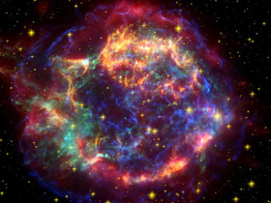
The science of modern cosmology, observational and theoretical, clearly indicates that, at one point in time, the whole universe was nothing but a cloud of ‘smoke’ (i.e. an opaque highly dense and hot gaseous composition).[1] This is one of the undisputed principles of standard modern cosmology. Scientists now can observe new stars forming out of the remnants of that ‘smoke’ (see figures 1 and 2).
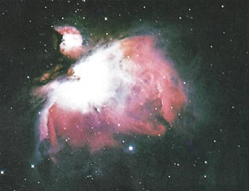
Figure 1: A new star forming out of a cloud of gas and dust (nebula), which is one of the remnants of the ‘smoke’ that was the origin of the whole universe. (The Space Atlas, Heather and Henbest, p. 50.)

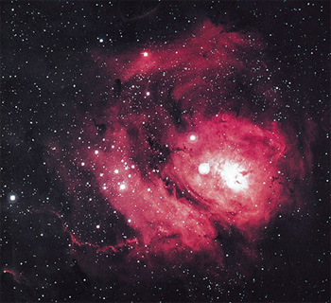
Figure 2: The Lagoon nebula is a cloud of gas and dust, about 60 light years in diameter. It is excited by the ultraviolet radiation of the hot stars that have recently formed within its bulk. (Horizons, Exploring the Universe, Seeds, plate 9, from Association of Universities for Research in Astronomy, Inc.)

The illuminating stars we see at night were, just as was the whole universe, in that ‘smoke’ material. God has said in the Quran:
“Then He turned to the heaven when it was smoke...” (Quran 41:11)
Because the earth and the heavens above (the sun, the moon, stars, planets, galaxies, etc.) have been formed from this same ‘smoke,’ we conclude that the earth and the heavens were one connected entity. Then out of this homogeneous ‘smoke,’ they formed and separated from each other. God has said in the Quran:
“Have not those who disbelieved known that the heavens and the earth were one connected entity, then We separated them?...” (Quran 21:30)
Dr. Alfred Kroner is one of the world’s renowned geologists. He is Professor of Geology and the Chairman of the Department of Geology at the Institute of Geosciences, Johannes Gutenberg University, Mainz, Germany. He said: “Thinking where Muhammad came from . . . I think it is almost impossible that he could have known about things like the common origin of the universe, because scientists have only found out within the last few years, with very complicated and advanced technological methods, that this is the case.”[2] (To view the RealPlayer video of this comment click here). Also he said: “Somebody who did not know something about nuclear physics fourteen hundred years ago could not, I think, be in a position to find out from his own mind, for instance, that the earth and the heavens had the same origin.”[3] (View the RealPlayer video of this comment).

Footnotes:
[1] The First Three Minutes, a Modern View of the Origin of the Universe, Weinberg, pp. 94-105.
[2] The reference for this saying is This is the Truth (videotape). For a copy of this videotape, please visit this page.
[3] This is the Truth (videotape).

